**Table of Contents**

1. Abstract
2. Introduction
3. Carbon Flux and Its Importance
4. Stokes Law and Predicting Sinking Speeds  
   A. Particle Size and Sinking Speed Estimates  
   B. Global Maps of Important Environmental Variables that are measured by satellite (T, S, μ)  
   C. Particle Size Distribution and Global Carbon Flux Estimates
5. Sediment Trap Data
6. Comparisons Between Data
7. Discussion
8. Citations

**Abstract**

The abstract will outline the essential topics of the thesis and condense it into a short and digestible package.

The ocean sequesters carbon in the deep ocean via the production and sinking of particulate organic carbon from the surface. Understanding the sequestration of carbon by requires accurate prediction of the size-dependent sinking speeds of diatoms. Particulate sinking speeds can be calculated using Stokes’ Law, which predicts sinking speed based on the particle’s radius and density. Additionally, an extended model is used to predict the sinking speeds of diatoms by accounting for the additional frustle of the diatom. Estimates of global carbon export out of the euphotic zone by sinking are generated by estimating the sinking speed of different phytoplankton size classes using both estimation methods. The satellite data used to generate the estimate includes sea surface temperature, sea surface salinity, and phytoplankton distribution data. The resulting estimates are compared to observed sediment trap data, with a correlation of r2 = 0.0647.

**Introduction**

The introduction will give background to the paper, reference relevant papers (Kostadinov et. al 2009, 2016, MIT Seawater Papers, Mouw Dataset), as well as stating the main points of the thesis: The mathematical concepts of Stokes Law (force balance between gravity and the friction of the fluid), satellite data and its resulting plots, comparisons sediment trap data. It will also outline the general structure for the paper.

Carbon is exchanged between many systems throughout the world. A prominent form of Carbon that is exchanged between many ecosystems is CO2. The ocean is important to study because it is a crucial part of the world’s CO2 cycle. The biological pump is a process where phytoplankton particles sink and remineralize out of the well-lit mixed layer to the deep ocean and serves as a key method for the sequestration of atmospheric carbon. Estimating carbon export within the ocean is difficult, with studies predicting a large range of 5 to 12 Petagrams of carbon yearly exported from the euphotic zone (Siegel et al 2014). Creating new methods to measure and estimate the export of carbon is an important way to decrease the uncertainty in the carbon export estimate. Furthermore, sediment trap data of phytoplankton sinking speeds is sparse in space and time. Satellite data offers superior spatial and repetitive coverage, which motivates the creation of models that can estimate carbon export from satellite data. Satellite data has also recently been used to estimate the distribution of different particle size classes of phytoplankton in the ocean from backscattering, which is used to create an estimate of global carbon export.

**Stokes Law and Predicting Sinking Speeds**

**A****. Particle Size and Sinking Speed  
 i. Basic Stokes Law**

Sinking speeds of phytoplankton are often estimated by Stokes’ law, which predicts sinking velocities that scale by an exponent of 2 in relation to its radius. Sinking plankton particles satisfy the prerequisites of Stokes’ Law, as they are small, slow moving spherical objects that move slowly in relation to its outside medium. Using a newer model predicts that diatoms, which synthesize approximately half of the ocean’s fixed carbon (Nelson et al 1995; Field et al 1998, cited within Miklasz et al 2010), may follow a more complex extended Stokes Law that accounts for the differing densities of diatomic components (Miklasz and Denny 2010).

The classic stokes model predicts that a sinking particle’s speed (U) is:

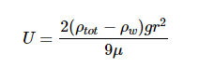

Where ρtot is the density of the particle, ρw is the density of the surrounding liquid (in this case water), r is the radius of the particle, g is the constant of gravitational acceleration (9.8 m s-2), and μ is the dynamic viscosity of surrounding liquid (water).The extended model presented by Miklasz and Denny (2010) assumes constants of ρw = 1023 kg m-3 and μ = 1.07 x 10-3 Pa s, which represents the density and dynamic viscosity of water at 20°C and 33 g L-1 salinity, respectively. Stokes’ law holds up for particles with small Reynolds numbers (Re < 1), which describes all particles mentioned in this paper. Since both dynamic viscosity and water’s density varies with temperature and salinity, it is important to consider both variables within our calculation. However, because the range at which water’s density varies with respect to temperature and salinity differences is so small, we can safely assume water to have a constant density of ρw ≈ 1023 kg m-3. Since dynamic viscosity is a large factor in this equation (Fig. 1), we include the variation of dynamic viscosity within our calculation. Dynamic viscosity (μ) is a key variable in Stokes Law that is overlooked. Miklasz and Denny (2010) assume that dynamic viscosity remains constant. Dynamic viscosity depends on temperature and salinity, and is dominated by the effects of the former (Fig. 1). The effect of dynamic viscosity is also apparent over the relevant temperature range (Fig 2). In order to calculate the change in dynamic viscosity, we use a seawater toolbox that estimates dynamic viscosity of seawater given temperature and salinity (Sharqawy et al 2010). Using this basic Stokes’ law model, sinking speed ( “U” ) is estimated for diatoms with small, medium, and large radii, with values of 5 μm, 10 μm, and 20 μm, respectively (Fig. 3). The sinking velocity of each particle increases by an exponent of 2, which greatly overestimates the sinking speed of larger particles.

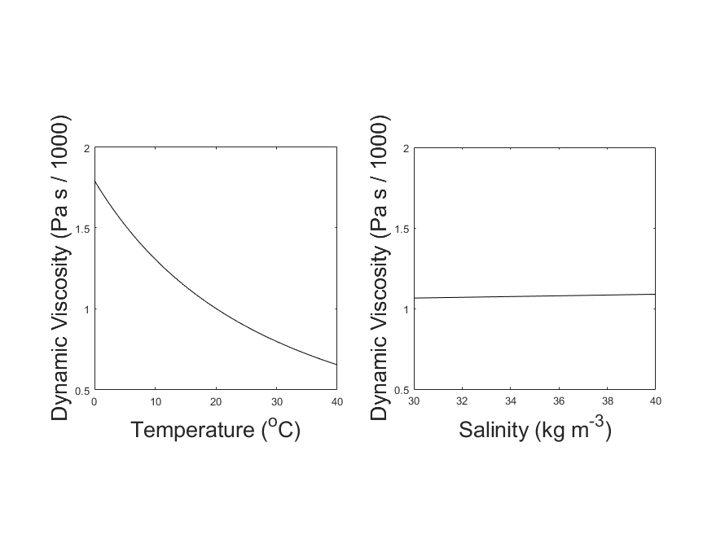

**Figure 1:** Variation in Dynamic Viscosity of Seawater (μ). Viscosity is plotted against temperature, while holding salinity constant at 35 kg m-3 (left). Viscosity is also plotted against salinity, while holding temperature constant at 20oC (right). Over the normal range of each variable, the change in viscosity is dominated by the effect of Temperature.

**(viscosityplot.m)**

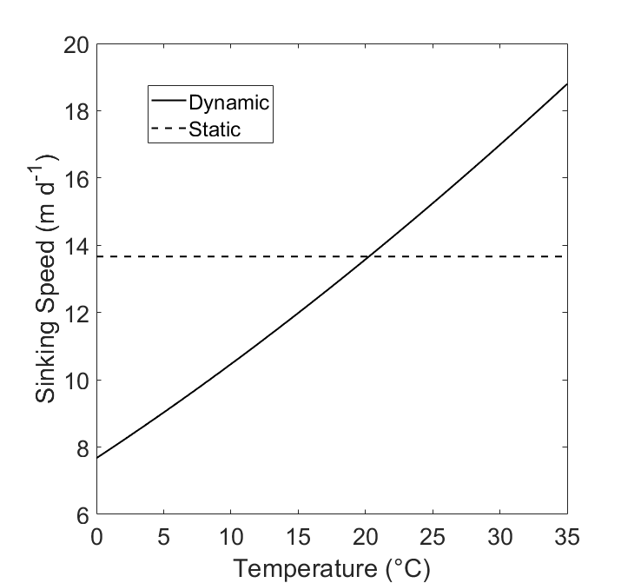

**Figure 2:** The hypothetical sinking speed (“U”) of two cells with identical structure, calculated with and without dynamic viscosity. The solid line (“Dynamic”) represents a model that uses the effect of temperature as it increases from 0°C to 35°C. The dashed line (“Static”) represents a sinking The cell is plotted where r = 10 μm and has a uniform cell density of ⍴tot = 1800 kg m-3.

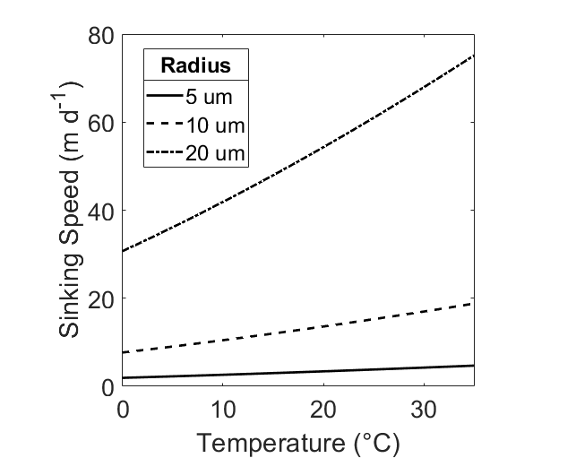

**Figure 3:** Sinking speed (U) in meters per day, calculated by Stokes’ Law. Hypothetical radius values of r = 5 μm (dashed), r = 10 μm (solid), and r = 20 μm (dot / dash) are displayed. Temperature range is 0oC ≤ T ≤35oC, Salinity S = 35 ppt, total cell density ⍴tot = 1800 kg m-3.

**(SpeedPlot_Viscosity_Density_Temperature.m)**

**ii. Extended Stokes Model**

Stokes Law is defined for a spherical particle with uniform density, which does not perfectly describe a diatom’s structure. A diatom may have a hard, dense silicate frustle as well as a less dense cytoplasmic core. Diatomic frustles may constitute up to 70% silica, which is much denser than water (2500 kg m-3). The cytoplasm is less directly studied, with no direct measurement. The density of cytoplasm is said to be in the range of 1030 to 1100 kg m-3 (Smayda 1970). Diatoms constitute mostly cytoplasm, with the frustle thickness usually contributing less than half of the diatom’s radius. Because of this, the diatom’s sinking speed is usually overestimated by the normal Stokes’ equation. The proposed extended Stokes’ theorem (Miklasz and Denny, 2010) assumes a spherical shape and accounts for diatom radius and frustle thickness to produce an estimate of sinking speed that more accurately reflects the density of the entire cell. For a diatom with a cell radius r = 10 μm, the basic model predicts a sinking speed of , while the extended model predicts a sinking speed of , using a frustle thickness of 1 μm; neither of the estimates account for dynamic viscosity (Fig. 4). Additionally, Figure 4 displays the difference in both models when dynamic viscosity changes between temperatures of 0℃ and 35℃. Figure 5 displays sinking speed estimates of diatoms with different cytoplasmic and frustle densities, with radii r = 10 μm and frustle thickness 1 μm.

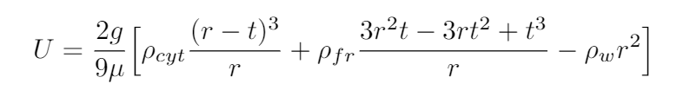

Equation 2: The Extended Stokes’ Model. ρcyt represents the density of the cytoplasm, ρfr represents the density of the frustle, ρw represents the density of water, r is the radius of the diatom, t is the thickness of the diatom’s frustle, g = 9.8 m s-2, the gravitational constant, and μ is the dynamic viscosity of seawater.

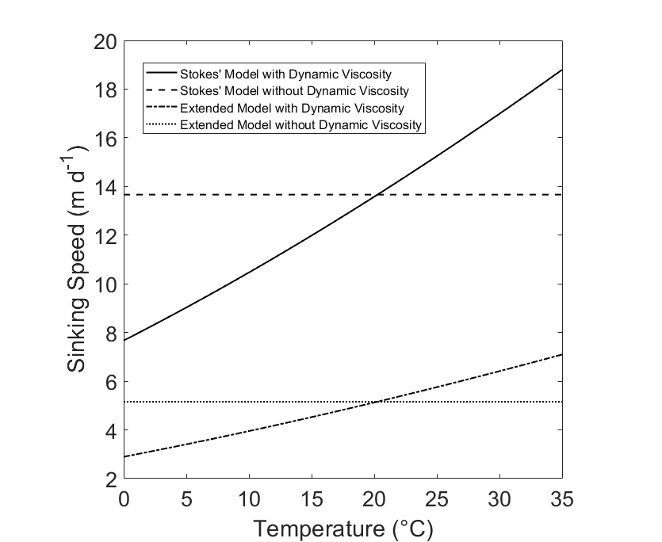

**Figure 4:** Comparisons between Stokes Model and Extended Model. Temperature range is 0oC ≤ T ≤ 35oC, Salinity S = 35 ppt. The basic Stokes Model assumes a cell radius of r = 10 μm and a uniform cell density of ⍴tot = 1800 kg m-3 (“Stokes’ Model”). The Extended Model assumes a cell radius of r = 10 μm, a frustle thickness of t = 1 μm, a cytoplasm density of ⍴cyt =1065 kg m-3, and a frustle density of ⍴fr = 1800 kg m-3 (“Extended Model”). Each model is presented with and without the influence of dynamic viscosity.

**(StokesDennysPlot.m)**

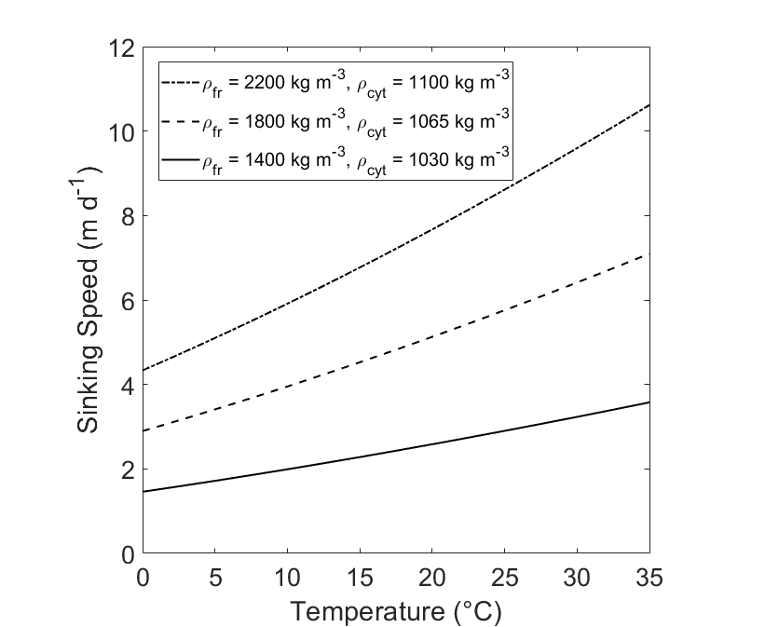

**Figure 5:** Comparison of Sinking Speed (U) of diatoms at different densities. Sinking Speeds are calculated using the Extended Model. The hypothetical diatoms have radius r = 10 and frustle thickness t = 1 μm

**(VariableDensity.m)**

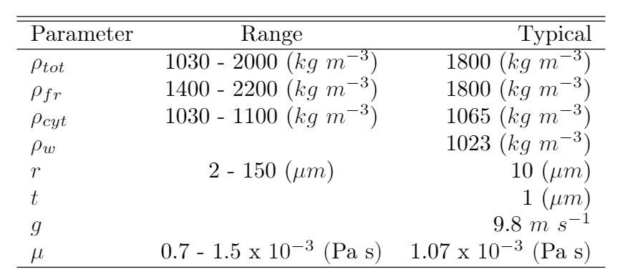

**Table 1: Typical values for variables relevant**

**(LaTeX doc)**

**B. Global Maps of Important Environmental Variables that are measured by satellite (T, S, μ)**

Dynamic viscosity is dependent on salinity and temperature. Using data gathered by satellites, we generate a yearly average sea surface salinity and sea surface temperature model. Sea surface salinity data is taken from the Aquarius satellite during the year 2012, using monthly averages at 1 degree resolution. Sea surface temperature data is taken from MODIS during the year 2012, using monthly averages at 1 degree resolution. Both sets of data are downloaded from the NASA OceanColor Website. A yearly average of both sea surface temperature and sea surface salinity is created using the data (Fig.6). Dynamic viscosity depends on the temperature and the salinity of seawater. Using both the sea surface salinity and the sea surface temperature data, a global map of the yearly average dynamic viscosity of the ocean is created (Fig. 7).

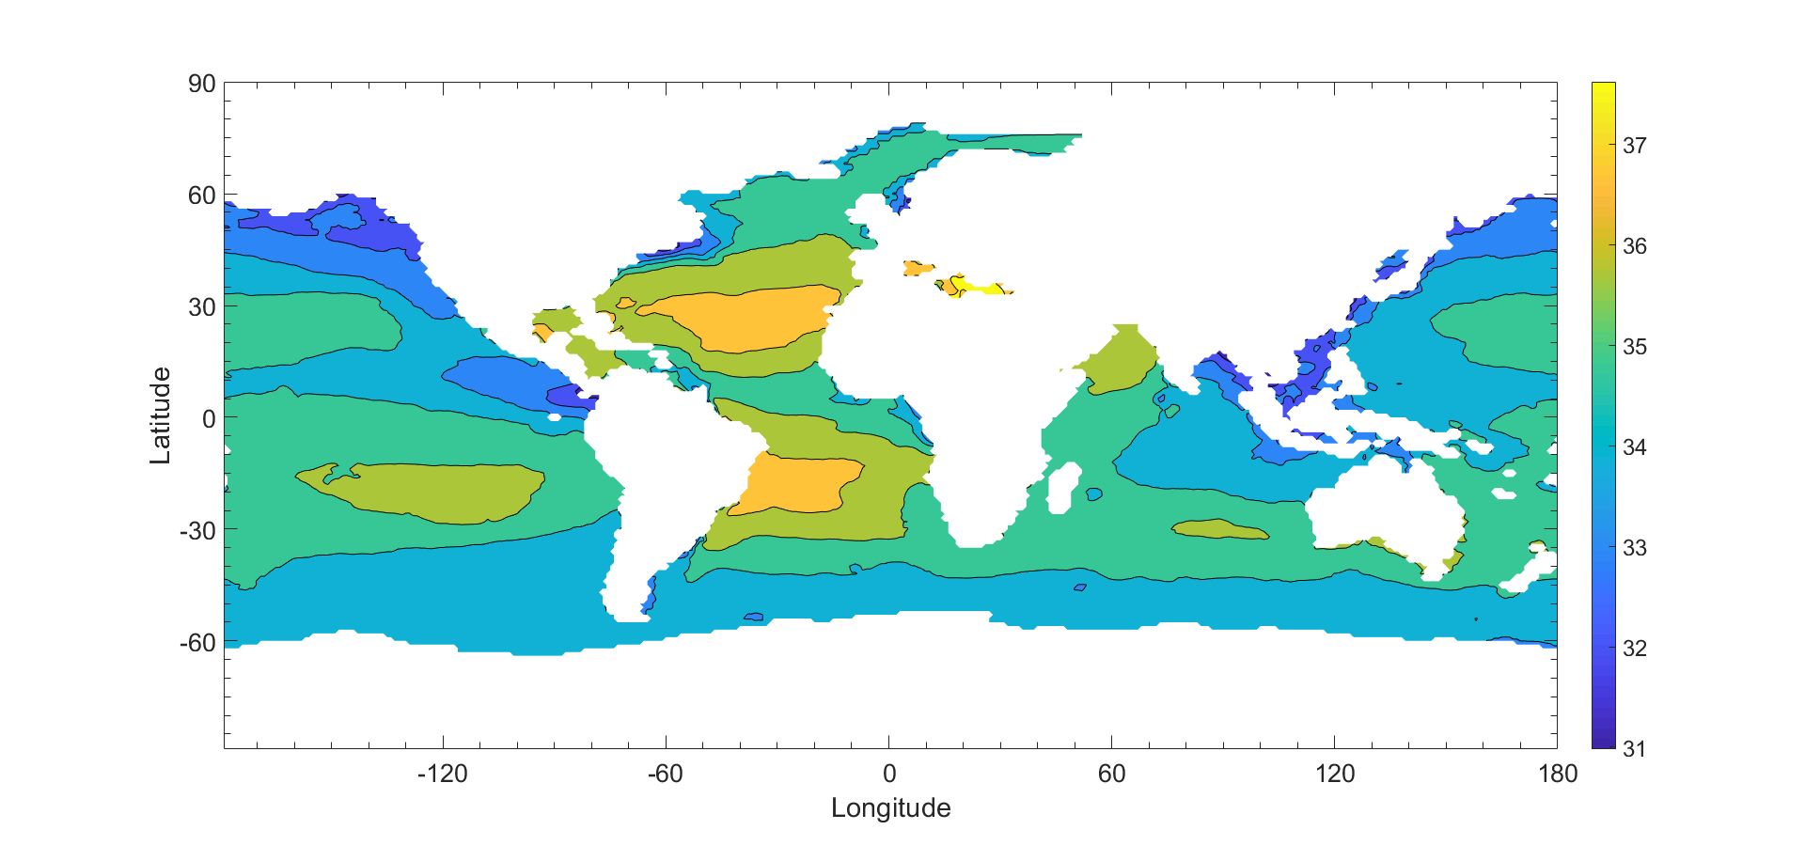

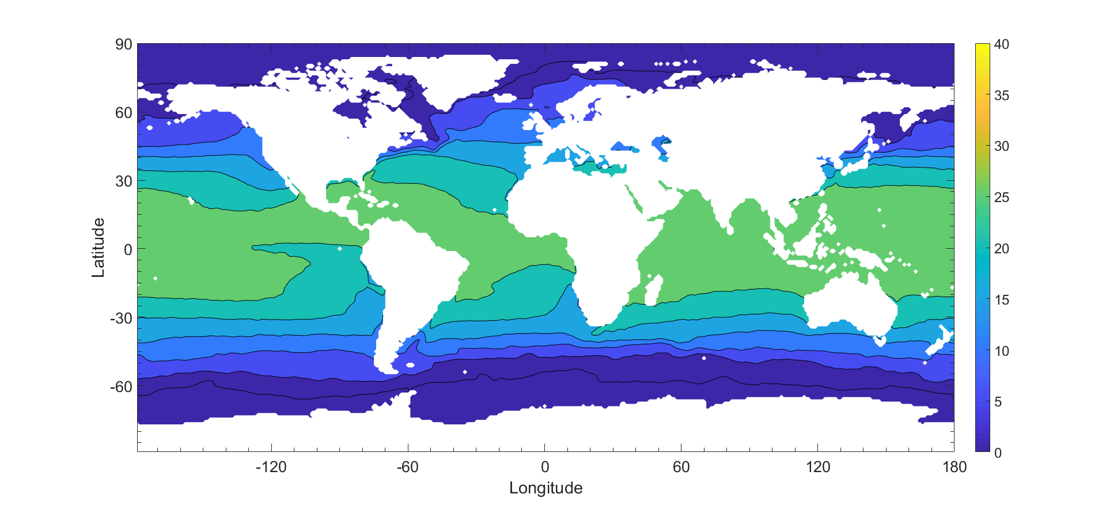

Figure 6: Global annual average of sea surface salinity (top) and temperature (bottom) for the year 2012.

(C_biomass.m)

C. Particle Size Distribution and Global Carbon Flux Estimates

The global distribution of phytoplankton particles can be estimated using satellite data from SeaWiFs (Kostadinov et al 2009). Phytoplankton can be ordered into three distinct size classes based on radii. The three size classes are microplankton, nanoplankton, and picoplankton, which are , respectively.

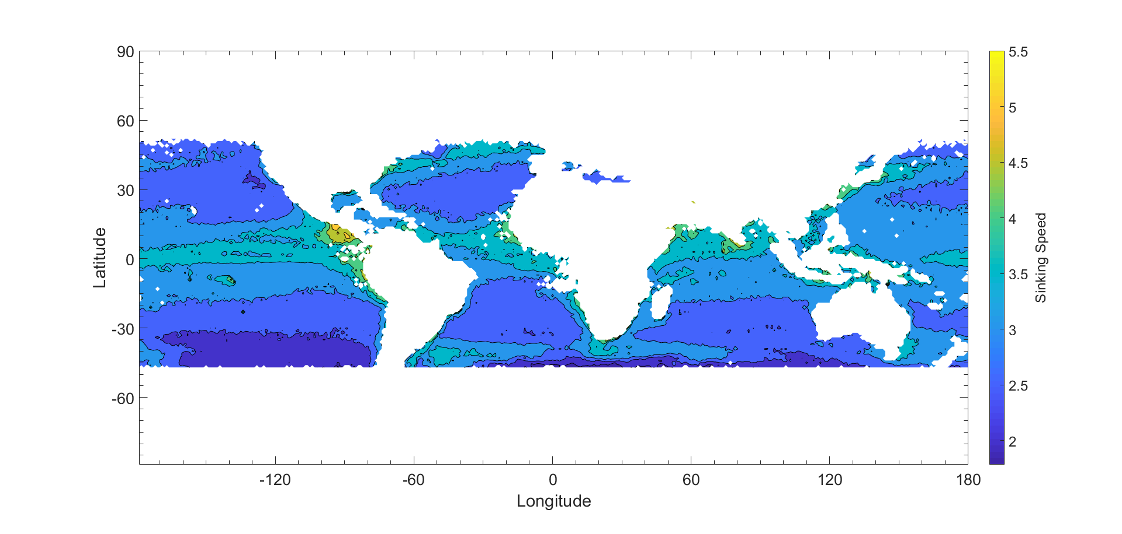

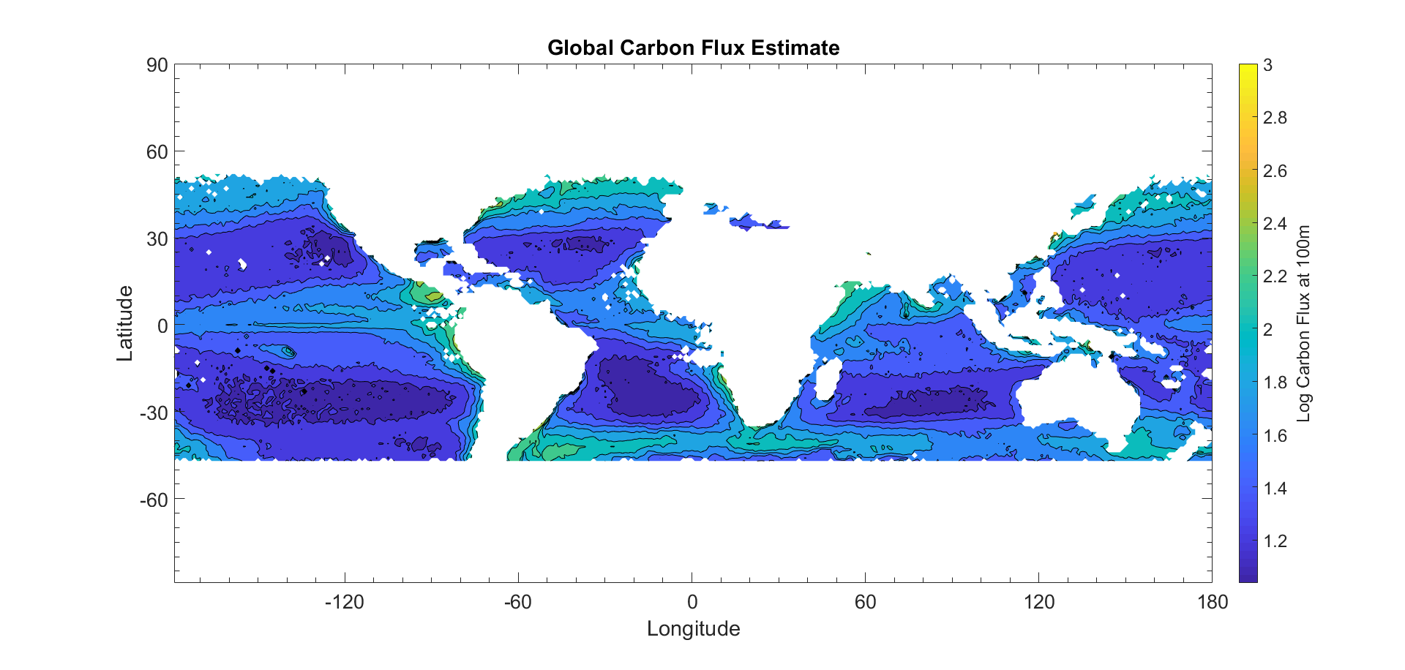

Figure 7: Global map of sinking speed estimate (top) and carbon export estimate (bottom).

(C_Biomass.m)

**Sediment Trap Data**

**Comparisons Between Data**

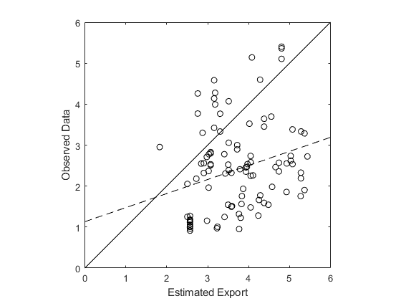

**Figure 10: A double-log plot of the estimated export vs sediment trap data (Mouw et al 2016). The solid line pictured is a 1:1 reference line. The dotted line represents the line of best fit for the data. The R2 value for the data is 0.0647.**

(C_biomass.m)

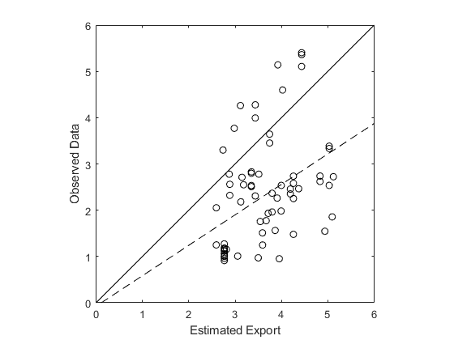

**Figure 11: A double-log plot of the estimated export vs sediment trap data (Mouw et al 2016). The solid line pictured is a 1:1 reference line. The dotted line represents the line of best fit for the data. The R2 value for the data is 0.145.**

**Citations**

Kostadinov, T. S., Siegel, D. A., & Maritorena, S. (2009). Retrieval of the particle size distribution from satellite ocean color observations. Journal of Geophysical Research, 114(C9). <https://doi.org/10.1029/2009jc005303>

Kostadinov, T. S., Milutinovic, S., Marinov, I., & Cabré, A. (2016). Size-partitioned phytoplankton carbon concentrations retrieved from ocean color data, links to data in NetCDF format, supplement to: Kostadinov, Tihomir S; Milutinovic, Svetlana; Marinov, Irina; Cabré, Anna (2016): Carbon-based phytoplankton size classes retrieved via ocean color estimates of the particle size distribution. Ocean Science, 12(2), 561-575 [Data set]. PANGAEA - Data Publisher for Earth & Environmental Science. <https://doi.org/10.1594/pangaea.859005>

Miklasz, K. A., & Denny, M. W. (2010). Diatom sinkings speeds: Improved predictions and insight from a modified Stokes’ law. Limnology and Oceanography, 55(6), 2513–2525. <https://doi.org/10.4319/lo.2010.55.6.2513>

Nayar, K. G., Sharqawy, M. H., Banchik, L. D., & Lienhard V, J. H. (2016). Thermophysical properties of seawater: A review and new correlations that include pressure dependence. Desalination, 390, 1–24. <https://doi.org/10.1016/j.desal.2016.02.024>

Sharqawy, M. H., Lienhard V, J. H., Zubair, S. M. (2010). Thermophysical Properties of seawater: A review of existing correlations and data. Desalination and Water Treatment, 16, 354-380.

<http://web.mit.edu/lienhard/www/Thermophysical_properties_of_seawater-DWT-16-354-2010.pdf>

Siegel, D. A., Buesseler, K. O., Doney, S. C., Sailley, S. F., Behrenfeld, M. J., & Boyd, P. W. (2014). Global assessment of ocean carbon export by combining satellite observations and food-web models. Global Biogeochemical Cycles, 28(3), 181–196. <https://doi.org/10.1002/2013gb004743>

Smayda, T. J. 1970. The suspension and sinking of phytoplankton

in the sea. Oceanogr. Mar. Biol.: Ann. Rev. 8: 353–414.